**Blake Conrad**

**IMSE 982 Final Project**

**07/20/2018**

# Introduction

The objective of this project is to answer three very specific non-linear programming problems with a unique implementation of specified algorithms. The objective of this technical write up is to explain how conclusions were drawn for each of the problems. The three-part problem is listed below:

1. Solve a quasi-convex problem, illustrating from several different starting points the global optimal solution for each converges to the same point.
2. Solve a non-convex problem that has multiple KKT points, illustrating from several different starting points the local optimal solution for each converges to a different point.
3. Solve a quasi-convex problem with two or more constraints, illustrating the barrier function approaches feasibility and converges to the correct global optimal solution.

Tools used were the Python programming language utilizing Numpy, Pandas, and Matplotlib packages. Python version 3.6 was used to test the results and produce all tables and charts. Jupyter notebooks were leveraged for speed and reproducibility under Anaconda 3 installation. Both Python files and Jupyter notebooks will be provided to illustrate each solution to the above listed problems. Algorithms implemented for these solutions included ***Golden Search*** (*Bazaraa, Sherali, Shetty p. 350)*, ***Conjugate Gradient Method*** – **Fletcher Reeves** (*Bazaraa, Sherali, Shetty p. 422-423),* and the ***Barrier Function Method***(*Bazaraa, Sherali, Shetty p. 469).* We now proceed to look at the functions selected, respective solutions, and details necessary to carefully articulate the solution.

# Problems Solved

## Problem 1

Quasi-convex function: Hyper-Bowl Function; $f:R^{3}→R$

$$f(x,y,z)=\left(x^{2}+y^{2}+x∙y\right)+\left(y^{2}+z^{2}+y∙z\right)+\left(x^{2}+z^{2}+x∙z\right)$$

$$∇f\left(x,y,z\right)=\begin{matrix}4x+y+z \\ 4y+x+z \\ 4z+x+y\end{matrix}$$

$$H\left(x,y,z\right)=\begin{matrix}4 & 1 & 1 \\ 1 & 4 & 1 \\ 1 & 1 & 4\end{matrix}$$

We select the function f displayed above. This function has many properties, and is indeed a hyper-bowl. *Illustration 1* shows an example of what this function looks like when a single dimension is held constant. The selected function for **Problem 1** is clearly convex, with a hessian that is strictly positive definite. Hence, we expect given several different starting points to see a unified point of convergence via the algorithm of choice. *Table 1* shows the output from the *Conjugate Gradient – Fletcher Reeves Method* using *Golden Search* on this function. As we can see, from 10 different randomly sampled starting points we converge on or very close to 0. With additional tolerance threshold $ε$ this value will continue to converge to 0. We can also note how many iterations each took and the final x position denoted $X[N]$.

***Illustration 1****:* Image to articulate a 4-dimensional surface with a single dimension (z) held constant at 0.

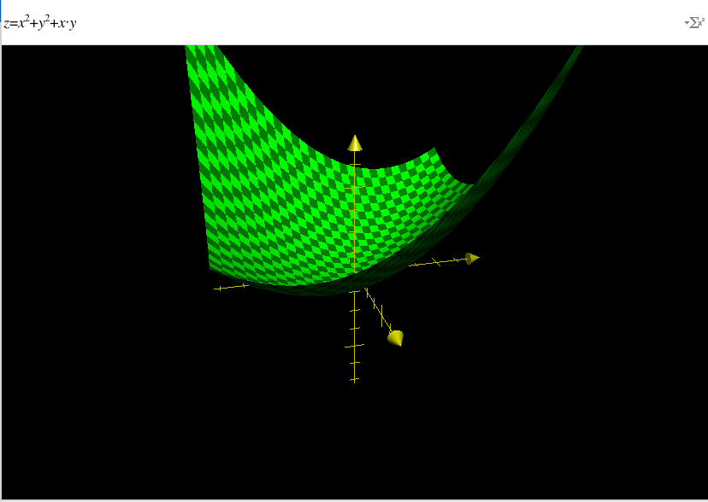

***Table 1****:* 10 Samples of *Conjugate Gradient – Fletcher Reeves Method* using *Golden Search* converging to the same point $\overline{x}=(0,0,0)$, with different starting points.

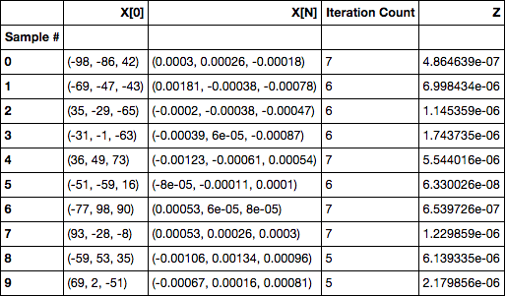

## Problem 2

Non Convex Function: Periodic Hyper-Wave Function; $f:R^{3}→R$

$$f\left(x,y,z\right)=\sin\left(x\right)∙\cos\left(y\right)+\frac{y}{z}+\frac{x}{z}$$

$$∇f\left(x,y,z\right)=\begin{matrix}\cos\left(x\right)∙\cos\left(y\right)+\frac{1}{z} \\ -sin\left(y\right)∙\sin\left(x\right)+\frac{1}{z} \\ -\frac{x}{z^{2}}-\frac{y}{z^{2}}\end{matrix}$$

$$H\left(x,y,z\right)=\begin{matrix}-\sin\left(x\right)∙\cos\left(y\right) & -\sin\left(y\right)∙\cos\left(x\right) & -\frac{1}{z^{2}} \\ -\cos\left(x\right)∙\sin\left(y\right) & -\cos\left(y\right)∙\sin\left(x\right) & -\frac{1}{z^{2}} \\ -\frac{1}{z^{2}} & -\frac{1}{z^{2}} & \frac{2x}{z^{3}}+\frac{2y}{z^{3}}\end{matrix}$$

We select the function f defined above. This function is known as a periodic wave function and provides us with the several properties including:

1. Only convex in certain periodic regions, denoted in Appendix A.
2. Provides many, nearby, local peaks and valleys.

Both properties mentioned above give us the ability to know that provided several randomly sampled points, we would expect them to converge in differently locations, but also be relatively close. This is because of the wave like properties we have highlighted. So looking at *Illustration 2*, we can begin to visualize this 4-dimensional surface by holding the 3rd independent variable, z, constant. So we see the whirlpool like wave structure mentioned above. This property is true if we hold the x and y variables constant at 0 or 1 as well. After running the *Conjugate Gradient – Fletcher Reeves Method* using *Golden Search* to optimize step sizes each iteration, *Table 2* was produced. We can see similar to *Table 1*, our starting points in the $X[0]$ column and our final point once we converged at $X[N]$. We can see we started at very different initial locations and landed in different final locations with varying z-values. Hence, we have evidence to believe that our function is what we claim and that not having convexity tells us our local optimal solution **is not** guaranteed to be global optimal. We expand *Table 2* with a visualization *Illustration 3* showing the convergence at different locations.

***Illustration 2****:* Image to articulate a 4-dimensional surface with a single dimension (z) held constant at 1.

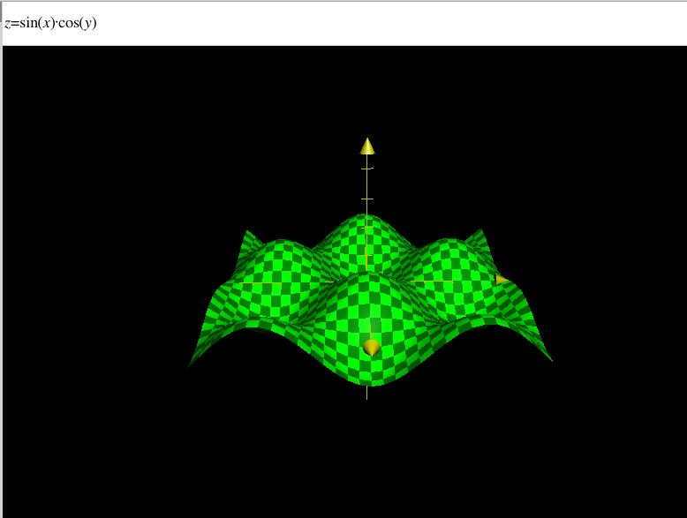

***Table 2***: 10 Samples of Conjugate Gradient Fletcher Reeves Method converging to different points with different starting points.

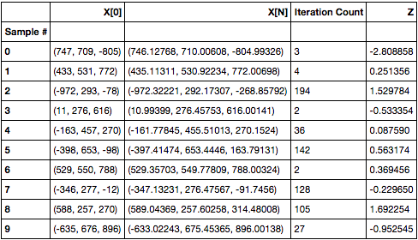

***Illustration 3****:* Display of each sample distant from one another with varying final points.

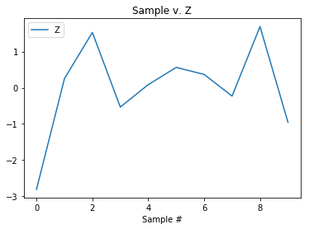

## Problem 3

Constrained Quasi-convex function: Hyper-Bowl Function; $f:R^{3}→R$

$$f(x,y,z)=\left(x^{2}+y^{2}+x∙y\right)+\left(y^{2}+z^{2}+y∙z\right)+\left(x^{2}+z^{2}+x∙z\right)$$

subject to:

$$g_{1}\left(x,y,z\right)=\left(x+y+z\right)≤1$$

$$g_{2}\left(x,y,z\right)=\left(x^{2}+y^{2}+z^{2}\right)≤1$$

The Barrier Function will be defined as

$$f\left(x,y,z\right)=\left(x^{2}+y^{2}+x∙y\right)+\left(y^{2}+z^{2}+y∙z\right)+\left(x^{2}+z^{2}+x∙z\right)+ μ[-\frac{1}{\left(x+y+z-1\right)}-\frac{1}{\left(x^{2}+y^{2}+z^{2}-1\right)}]]$$

The last function selected is identical to the first, providing properties of convexity as mentioned in **Problem 1**. However, in addition to just a single function, to ensure that a barrier function is working, we add two additional constraints. Both of these bound our solution and retain our optimal point from **Problem 1**; $\overset{̿}{x}=(0,0,0)$. Several geometric observations can be made before diving into the results tableau, we have a paraboloid as our main objective function, a hyper-plane, and a hyper-sphere bounding us inside of a hyper-polygon which contains our optimal solution. Another remark is that we expect $\lim_{μ→∞}{Min. f\left(x,y,z\right)=0}$. So for large values of $μ$ we will see infeasibility, but as we taper it down, we approach our value where our objective function is respecting the constraints sufficiently to account for approaching them. Therefore, after running the *Conjugate Gradient – Fletcher Reeves Method* using *Golden Search*, we get *Table 3* as our output. As expected, for $μ=1000, 100, 10, and 1$ we are infeasible. However, we become more and more optimal as we approach zero. We can see this in the visual in *Illustration 4* as well. Therefore, we can see that with a convex function under convex constraints, when a barrier method is applied, we can accurately approach the optimal solution and see the properties of feasibility as we grow closer to optimality. One notable difference between the solutions of **Problem 1** and **Problem 3** is that for this problem we have a fixed location to ensure we are approaching feasibility. In addition, for this problem we are trying to ensure we hit the global optimal solution, so we lean on the results of **Problem 1** as insurance.

***Table 3*:** Samples of Conjugate Gradient Fletcher Reeves Method converging to a single global optimal point as mu approaches 0.

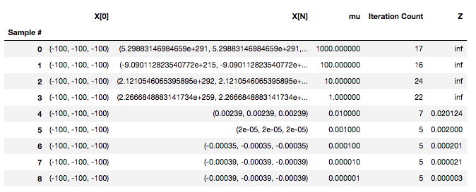

***Illustration 4:*** Display of barrier method converging to zero as the mu decreases exponentially.

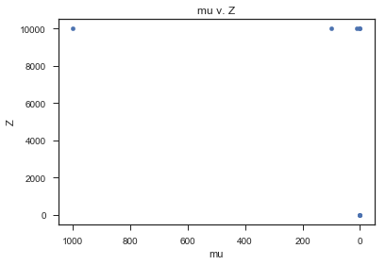

infinity

**Conclusion**

In this write up we have articulated several experiments. The first experiment, on convex functions, **Problem 1** and **Problem 3** show that a convex function will converge to one and only one point with the algorithms implemented and attached with this document. They also show that under the exposure of additional constraints and a barrier method, when the optimal solution is known, our program will provide the optimal solution as the parameter $μ$ approaches a sufficiently small number. This confirms our theories discussed in lecture about the barrier method, and hence sufficiently illustrates its execution for this problem. The second experiment, on non-convex functions, **Problem 2** showed a simple example of a period hyper-wave function that has several local optimal solutions just looking at a constant third independent variable in *Illustration 2*. We concluded from this experiment that our algorithm was also working correctly, in that the resulting optimal solution from several random starting points converged to differently solutions within proximity to one another, confirming the properties of our periodic wave function, and Fletcher Reeves Conjugate Gradient Method. Both experiments articulate the effectiveness of the algorithms demonstrated after chapter 6 of the text and give sufficient complexity to show a complex problem with an understandable and somewhat visual interpretation of the solution, satisfying the requirements provided.

*References*

*Bazaraa, M., S., Sherali, D., H., Shetty, C., M. Nonlinear Programming Theory and Algorithms Third Edition*. *Wiley Publication 2006.*

*Appendix A*

**Problem 2**

Regions where $f\left(x,y,z\right)=\sin\left(x\right)∙\cos\left(y\right)+\frac{y}{z}+\frac{x}{z}$ is convex.

* + ||